Name: Rishik Ramagiri Roll no: 2520030333
S-06

Basic Linux Commands

1.PWD
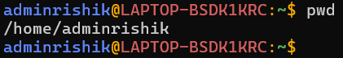

- Clear
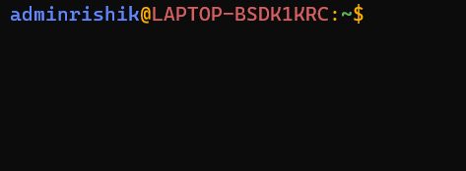

3.history
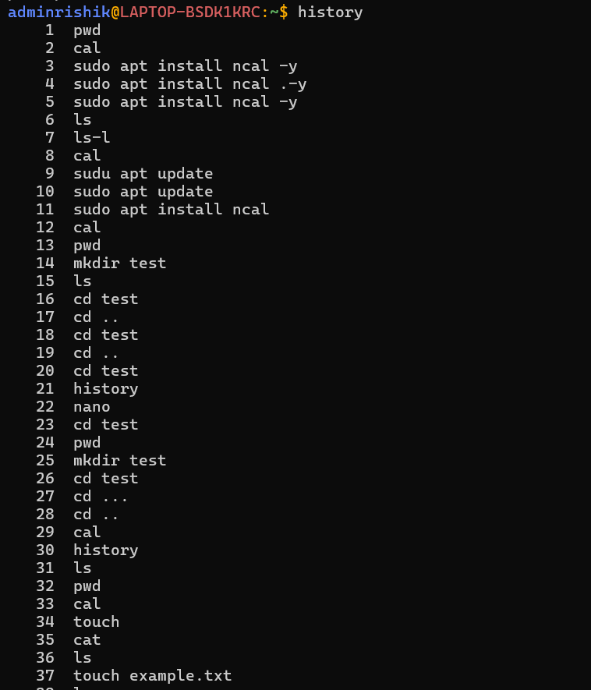

4.Whoami
5.Date
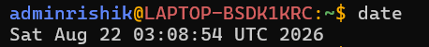
6.Calender
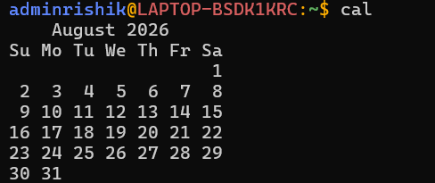

7.Hostname
